Mining Periodic Subgraphs in Drosophila Developmental Networks

Mohammad Shafiqul Islam
Department of Electrical and Computer Engineering
North South University
Dhaka, Bangladesh
mdshafiqul.islam@northsouth.edu
Mohammad Rafsun Jany Mahin
Department of Electrical and Computer Engineering
North South University
Dhaka, Bangladesh
jany.mahin@northsouth.edu
Ahsanur Rahman
Department of Electrical and Computer Engineering
North South University
Dhaka, Bangladesh
ahsanur.rahman@northsouth.edu

Abstract—For the past few years, periodic subgraph mining in dynamic networks has gained a lot of attention in different fields of research. However, not much work has been done in this regard in the field of network biology. This work attempts to fill this gap by finding subnetworks that appear periodically several times during Drosophila development. We first computed periodic subgraphs from a sequence of time varying gene networks using an existing tool. We suggested how to choose an appropriate parameter setting for this tool. We also did enrichment analysis of the largest connected component of the periodic subnetworks as well as the hub genes and dense subgraphs in it. Our results show that the proposed method can successfully identify periodically active gene-functions and transcription factors during the development of Drosophila. We have also compared our results with a baseline method which computes recurrent dense subgraphs in an ensemble of networks and found that the baseline method generates many spurious clusters irrelevant to the periodically active gene functions whereas our approach can successfully mine those functions.
Keywords—periodic subgraph, graph mining, Drosophila developmental networks, dynamic networks, functional enrichments

Introduction
In recent years, graph mining has attracted the attention of a lot of researchers. One of the main goals of graph mining is to find interesting patterns from one or more graphs. Such patterns include hubs [1], dense subgraphs [2], frequent dense subgraphs [3], periodic subgraphs [4], and so on. Different patterns are useful for different purposes. For example, hubs tend to indicate leaders in a social network and essential genes in a protein-protein interaction (PPI) network [5], dense subgraphs often reveal underlying communities in a social network [6], frequent dense subgraphs tend to indicate communities in a sequence of communication networks [7], periodic subgraphs tend to indicate periodically formed communities in dynamic social networks [4], and so on.
Among them, periodic subgraph mining is one of the least studied problems. Especially, we couldn’t find any study that identifies periodic subgraphs in time-varying protein/gene interaction networks. Therefore it is an important to fill up this gap in the extant body of knowledge. Moreover, these periodic subgraphs have high potential to give us interesting insights of the underlying biology of the cell. Our intuition comes from the following literature review.
It is well-known that multiple processes get activated periodically to regulate/maintain cell-cycle [9] and circadian rhythm (sleep-wake cycle) [10]. Periodic oscillation was also observed in the abundance of diverse cellular molecules such as cAMP secreted by starved Dictyostelium discoideum (period is about 5 min), cytosolic Ca⁺⁺ ion (period depends on cell type), transcription factor NF-KB (period is about 100 min), tumor suppressor p53 (period is a few hours), etc [10].
Biological experiments have also shown that some cellular functions and regulators are activated periodically during organism development. For example, cell cycle occurs every 30 min during amphibian embryonic development and is driven by the periodic activation of MPF [10]. In vertebrate embryos, Notch signaling pathway periodically activates cellular processes responsible for somitogenesis [10]. Motoneurons exhibit periodic bursts of activities during the early development of spinal cord in chick and mouse [8]. Also, during the development of mouse and some other vertebrates, a transient neural network cause the generation of periodic waves of activities in the retina (known as retinal waves) [9].
These literature reviews suggest that some subnetworks of genes in the development networks may arise periodically – (i) in order to regulate periodic cues and/or (ii) as a response to such cues. In fact, recent advances in experimental biology suggests that the intensities of molecular interactions within a cell vary spatiotemporally, thereby resulting in a dynamic interaction network [13]. Finding periodic subgraphs within such a dynamic network may shade light on both the periodic cellular processes and their regulators.
These observations motivated us to compute periodic subgraphs within time-varying gene networks. We made the following contributions in this work.
- We demonstrated the importance of mining periodic subgraphs in time-varying gene networks on the basis of extensive literature review.
- We suggested how to choose appropriate parameter combinations to compute periodic subgraphs and used those parameters to compute periodic subgraphs from a dataset of temporal gene networks.
- We computed the largest connected component of each periodic subgraph as well as the hub genes and dense subgraphs within that component. Then we have done a number of analyses on those to show that they are involved in known periodic processes and are regulated by periodic genetic regulators.
- We compared our results with a baseline method which computes recurrent dense subgraphs in an ensemble of networks and found that the baseline method generates many spurious clusters irrelevant to the periodically active gene functions whereas our approach can successfully mine those functions.
Rest of the paper is organized as follows. Section II illustrates the notion of periodic subgraphs. Section III discusses relevant works. Section IV sheds light on the network dataset we chose to compute periodic subgraphs and our justifications to choose it. Section V demonstrates our complete pipeline of finding periodic subgraphs and analyzing them for their biological significance. We discuss our results in Section VI. We conclude in Section VII and provide future directions in Section VII.

Periodic Subgraph Illustration
We demonstrate the concept of periodic subgraphs in the temporal networks shown in Fig. 1. This figure shows first six snapshots of a time-varying network over eight genes. Here each node is a gene involved in Drosophila’s development and an edge exist between two genes if they are likely to be co-regulated (see Section IV for details). These genes were chosen because they are biologically interesting. Specifically, Nrt, dock, brm, Src64b, and msn are involved in neuron projection guidance and the master regulator gene Notch (N) regulates this process []. Thus this network dataset serves as a motivating example for periodic subgraphs.

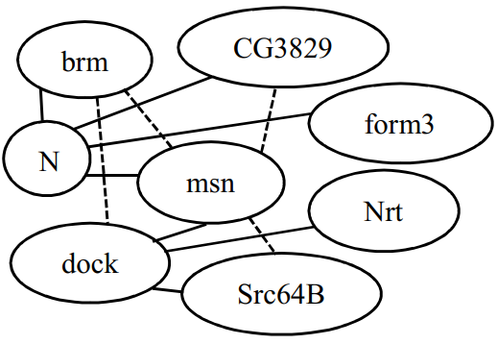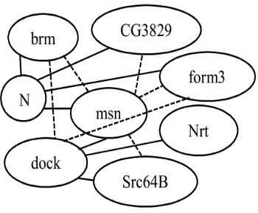
T = 1
T = 2

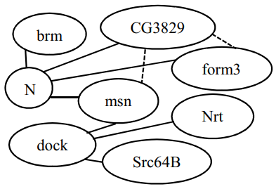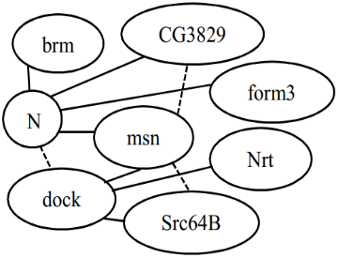
T = 4
T = 3

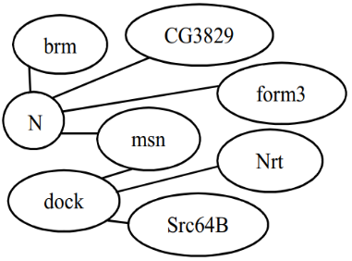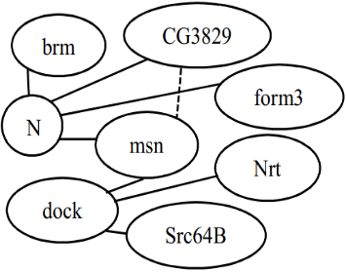
T = 6
T = 5

- First six snapshots of Drosophila developmental network over eight genes. Here the graph G₆ is a periodic subgraph having period 2, and support 3 with support sequence [2, 4, 6]. Straight lines represent edges which are present at all timesteps and dotted lines indicates varying edges.
Consider the last graph G₆ in this figure. The sequence of timesteps in which G₆ occurs is [1, 2, 3, 4, 6]. We call this sequence the support sequence of G₆. As it occurs at every timestep from 1 to 4, we call it a periodic subgraph with period 1 and support 4, or a (1, 4)-periodic subgraph, in short. To be precise, we call it a (1, 4)-periodic subgraph having support sequence [1, 2, 3, 4]. G₆ can also be called a (2, 3)-periodic subgraph with support sequence [2, 4, 6] because it occurs at 3 timesteps where consecutive steps are always 2 steps apart, i.e., it has period 2 and support 3.
With this illustration, we are now ready to present the formal definition of periodic subgraphs.
Definition 1. Periodic Subgraph: Given a dynamic network G, a subgraph F is called a (p, s)-periodic subgraph with support sequence S in G if it satisfies the following conditions.
- Periodicity: Consecutive timesteps in S must always be p steps apart.
- Minimum Support: The support, i.e., the length of the support sequence, |S| must be ≥ $σ$, where $σ$ is a support threshold given by the user.
- Structural Maximality: No other nodes or edges can be added into subgraph F because if we do so then the modified F does not have period p or support s anymore.
- Temporal Maximality: No other timestep can be added to the support sequence S because F is absent in G at timestep S₁ – p as well as at timestep S_{|S|} + p.
Note that our notion of periodic subgraph is equivalent to the concept of “periodic subgraph embedding” defined by Lahiri and Berger-Wolf [4].
We now demonstrate that G₆ is indeed a (1, 4)-periodic subgraph with support sequence [1, 2, 3, 4] according to these conditions. Specifically, it is both structurally and temporally maximal: … . G₆ is also a (2, 3)-periodic subgraph with support sequence [2, 4, 6] because

Related Works
To the best of our knowledge, no research before this one was conducted to identify periodic subgraphs in time-varying gene networks in order to elucidate their biological significance. Therefore we discuss other works that are closely related to us. We can classify these works into the following two categories.
Mining Periodically Co-expressed Genes: Some research applied mathematical/statistical techniques (for example, Fourier analysis) upon temporal gene expression profiles in order to discern clusters of genes that are periodically co-expressed [14], [15]. These works are not applicable to temporal gene networks – which are becoming more and more available with the recent development of novel experimental techniques.
Mining Periodic Subgraphs in Social Networks: Lahiri and Berger-Wolf [4] developed a mining algorithm called PSEMiner which maintains a list of periodic subgraphs for each timestep that was read so far. This process continues till the last timestep T. Their algorithm had a time complexity of O((V+E)T³lnT) for vertex V, edge E when the parameter P_{max} (maximum periodicity) is not given and O((V+E+P_{max}²) T²lnT) when P_{max} is given. Their purpose was to find the least set of periodically recurring subgraphs that earn the periodic behavior in a dynamic network.
Apostolico, Barbares and Pizzi [10] were interested in finding the graphs that recur at regular interval. From all periodic graphs, their particular concern was in those that cannot be enriched by adding new edges without losing support.
Later, they built an algorithm named ListMiner with time complexity O((E+V)(T² ln(T/σ)). The uniqueness of this algorithm is it does not need to know population in advance. So, it added the new incoming vertex online. They found that their algorithm outperformed PSEMiner on most datasets. As ListMiner had a better performance we used ListMiner to find the periodic subgraphs in our work.

Dataset
To be able to identify periodic subgraphs, we needed a time-varying network dataset. We collected a dataset [13] consisting of 66 undirected networks for this purpose. These networks were inferred from the temporal expression profile of 588 genes involved in the development related processes in Drosophila. Each network represents the binary associations among these 588 genes at a certain timestep during Drosophila’s development and an edge between two genes in it indicates that these genes are probably co-regulated at that timestep.
The procedure to infer these networks is briefly described here in order to make the reader understand our rational and motive for choosing this dataset. Firstly, a microarray dataset was collected. This dataset contained temporal expression of 4028 genes sampled at 66 distinct time-periods over the first 40 days Drosophila’s life, spanning four stages of its development: embryonic stage, larval stage, pupal stage, and adult stage [14]. Then a type of logistic regression method (called kernel reweighed l1-regularized logistic regression, or KELLER, in short) was applied on only the expression profiles of development-related genes (588 of total 4028 genes) in such a way that – (i) there should be an edge between two genes at timestep t if their expressions vary in a correlated manner near t and (ii) temporally adjacent networks share many more interactions than the distant ones (this is achieved by assigning more weights to the observations near timestep t and gradually decreasing the weights assigned to distant observations). This second constraint tries to ensure that the topology of the inferred networks changes slowly/smoothly over time. Therefore periodic subgraphs are less likely to arise in such networks due to a spurious correlation at a certain timestep. Another reason to choose this dataset is that it allows us to elucidate periodic processes across distinct timesteps within a developmental stage as well as over diverse stages.

Methodology
Our methodological pipeline for mining and analyzing periodic subgraphs in Drosophila developmental networks consists of several stages (Fig. 2). We wrote Matlab and Python scripts for processing inputs/outputs in different stages of our pipeline. We used a Windows 64- bit machine with 8 GB RAM and 4 2.3 GHz Intel i5 CPU cores for all our operations.

- Flowchart depicting our of methodology for mining and analyzing periodic subgraphs in Drosophila developmental network.
We discuss the stages of our pipeline in details below.

Preprocessing
We collected 66 networks derived in [13] from the URL: http://www.sailing.cs.cmu.edu/main/?page_id=431. These networks are available in Matlab format and the 588 genes of these networks are specified as numeric values (representing line numbers of another file containing the symbols of all 4028 genes of [14]). We first converted these files to an “edgelist” formatted text file, i.e., each line of this file indicates the timestep or network-index and the symbols of the two genes forming an edge in that network. There were total 249382 edges in this file after removing the duplicates where the number of edges in a timestep varied from 3434 to 4124.
ListMiner expects the input file to have a different format. Specifically, each line of the ListMiner input file must start with the timestep followed by the ids (numeric values) of nodes and edges that are present in that timestep-specific network. If the input networks have total n genes and m unique edges (here n = 588 and m = 17891) then ListMiner assumes that the genes have ids 1 to n and the edges have ids from n+1 to n+m. Therefore we created a mapping that maps our nodes (genes) and edges to numeric values amenable to ListMiner. We used this mapping to convert our edgelist formatted file to a suitable input file for ListMiner. We also used this mapping later for post-processing ListMiner outputs in order to identify the genes present in the periodic subgraphs.

Choosing Parameters
We applied ListMiner on the pre-processed input using a range of (period, support) parameter combinations. Specifically, we varied period from 2 to 66/3 and support from 3 to 66/(current value of period). We excluded period 1 and support ≤ 2 from our consideration because firstly, we didn’t intend to compute continuously occurring subgraphs (i.e, periodic subgraphs with period 1) in this work and secondly, periodic subgraph with very low support may arise simply due to noise. The maximum value of period was set to be 66/3 because our minimum value of support was 3. The rational for the maximum value of support is similar.
In order to select appropriate parameter combinations, we prepared two tables. One of them shows the number of subgraphs for each combination of parameters (Table I). The other shows the total number of unique genes covered by the subgraphs that we have found for each combination of parameters (Table II).
- Number of Periodic Subgraphs for Each Parameter Combination. Empty cells indicate that no periodic subgraph satisfy that period and support requirement
Periods | Supports
 | 3 | 4 | 5 | 6 | 7 | 8 | 9
2 | 692 | 415 | 267 | 160 | 104 | 57 | 33
3 | 491 | 244 | 127 | 60 | 34 | 17 | 8
4 | 388 | 156 | 64 | 27 | 11 | 4 | 3
5 | 300 | 101 | 35 | 10 | 5
6 | 243 | 70 | 18 | 5
7 | 189 | 42 | 10
8 | 149 | 25 | 3
9 | 144 | 15

- Number of Unique Genes Covered by the Subgraphs for Each Parameter. Empty cells indicate that no periodic subgraph satisfy that period and support requirement
Periods | Supports
 | 3 | 4 | 5 | 6 | 7 | 8 | 9
2 | 585 | 485 | 355 | 232 | 149 | 103 | 10
3 | 498 | 333 | 147 | 92 | 15
4 | 394 | 160 | 12
5 | 279 | 93
6 | 171 | 21 | 2
7 | 113 | 7 | 2
8 | 28 | 2
9 | 21 | 2

These tables show that both the number of periodic subgraphs and the number of unique genes in these subgraphs decreases with the increase of the period or support or both. This is expected because few subgraphs satisfy high period and/or support requirements. Another interesting finding is that the genes of a parameter are the subset of its ancestors (both period and support).
Based on these observations we decided to choose parameters in such a way that (i) both of period and support are not too low and (ii) number of genes is not too low. Our reasons for choosing parameters in such a way are as follows. Firstly, there exist numerous periodic subgraphs with very low period and support (see top-left corner of table I) which indicates that most of them exhibit periodicity probably because of noise rather than due to actual biological cues. Secondly, one of our goals was to understand why a set of genes show periodic inter-connections. Are they involved in any periodic process in the cell (such as cell cycle)? Are they regulated by a periodically active transcription factor (TF)? Definite answers to such questions can’t be obtained if the number of genes in the concerned gene-set is too low. Because small sets of genes tend to share many biological functions (a phenomenon known as multi-functionality []) and as such it is difficult to pinpoint the processes because of which these genes exhibit periodicity. That’s why we stipulate that the number of genes in a periodic subgraph cannot be too low. Specifically, we suggest that the number of genes shouldn’t be less than a hundred which is a typical cut off used in functional enrichment analyses [].
Applying these heuristic rules, we selected two parameter combinations: (period 2, support 8) and (period 7, support 3). These parameter choices are highlighted in Table II (the colored two cells). We chose these two parameter settings in order to investigate both types of periodic subgraphs: the ones with small period but large support as well as the ones with large period but small support.

Analyzing Periodic Subgraphs
There are 57 (respectively, 189) (2,8)-periodic subgraphs (respectively, (7,3)-periodic subgraphs). Many of them have multiple connected components. Among all the components in each of these periodic subgraphs, the largest component was chosen for biological significance analysis. The reason for choosing the largest component is that connected set of genes/protein tend to be more biologically meaningful than disconnected ones [] and large set of genes tend to be more meaningful than the smaller ones []. The largest components are shown in Fig. 3 – 4 and their properties are described in Table III.
- Number of Unique Genes Covered by the Subgraphs for Each Parameter
Parameters | Support Sequence | # Genes | # Edges
Period 2, Support 8 | 1, 3, 5, 7, 8, 9, 11, 13 | 33 | 56
Period 7, Support 3 | 1, 8, 15 | 39 | 64

We used FlyEnrichr tool [] to check if the overlap of the genes in each of these components with any GO [] biological process (BP) term is statistically significant (if yes, we call the component to be “highly enriched” in that GO term) or not. GO terms with more significant overlap has lower adjusted p-value and higher score. Top five GO BP terms with highest scores are shown in Table IV.

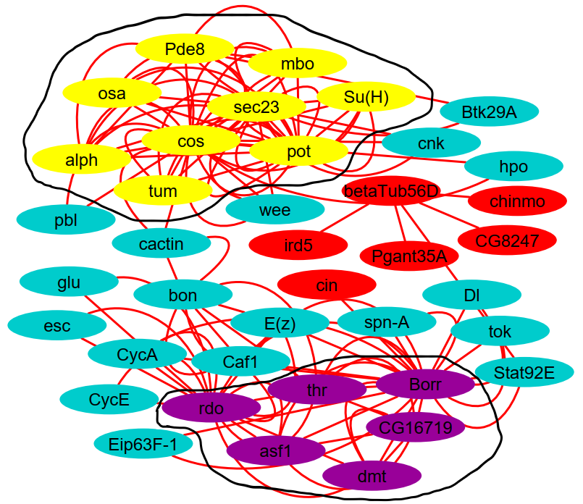
- Largest Connected Component of the parameters. Both parameters has the same nodes except the red cloroed ones for Period 2, Support 8. The black circled yellow and purple colored nodes represents the two dense subgraphs for both parameters.
We know that high degree nodes (a.k.a., “hub genes”) in co-expression networks tend to be essential genes. We wanted to investigate whether hubs in our largest component have any such interesting role. So we sorted the genes in the largest component based on their degrees and used FuncAssociate tool [12] to check if this ranked list is highly enriched in any GO term.
Since each edge in our network indicates a co-regulated relationship, genes in a dense subgraph in it should be regulated by the same regulator. To test this hypothesis, we applied ClusterOne algorithm [] (using default parameters) on each largest component to identify dense subgraphs in it. Then we used FlyEnrichr to check how enriched these clusters are in the genes regulated by known transcription factors (TFs) of Drosophila. We have also sorted these TFs by their adjusted p-values and applied FuncAssociate on this ranked list to compute its enrichment in GO terms.
We used Cytoscape network visualization and analysis platform [] for all network analysis related tasks mentioned in this section. We summarized all our enrichment results using ReviGO [] and present only top five GO terms with highest FlyEnrichr score which have ReviGO dispensability value less than 0.35. We discuss our results from these analyses in the next section.

Results

Largest component genes participate in periodic processes

- FlyEnrichr (FR) with Revigo Enrichment of GO Biological Process (p2s8)
ID | Name | FR Adj. p- value | FR Score
GO:1902808 | positive regulation of cell cycle G1/S phase transition | 4.64E-05 | 40.5
GO:0007422 | peripheral nervous system development | 2.33E-10 | 39.7
GO:0031062 | positive regulation of histone methylation | 1.62E-03 | 34.1
GO:0007476 | pmaginal disc-derived wing morphogenesis | 7.01E-10 | 30.2
GO:0060541 | pespiratory system development | 2.33E-06 | 25
- FlyEnrichr (FR) with Revigo Enrichment of GO Biological Process (p7s3)
ID | Name | FR Adj. P- value | FR  Score
GO:1902808 | positive regulation of cell cycle G1/S phase transition | 8.16E-05 | 39
GO:0007422 | peripheral nervous system development | 1.06E-09 | 37.7
GO:0031062 | positive regulation of histone methylation | 2.54E-03 | 32.8
GO:0060541 | respiratory system development | 2.20E-07 | 28.8
GO:0007476 | imaginal disc-derived wing morphogenesis | 4.75E-09 | 28.1

Hub genes are involved in periodic processes
- FuncAssociate enrichment of sorted (by degrees) list of nodes in the largest component
Highly Enriched GO Term | LOD ratio | Adj. P-value
CAF1 Complex | 2.58 | 0.04
Nucleosome Assembly | 2.02 | 0.019
Protein-DNA Complex Assembly | 2.02 | 0.019
Chromatin Organization | 1.29 | 0.001

Densely connected genes are regulated by periodically active regulators and processes
- Transcription Factor (TF) Enrichment Using FlyEnrichr (ER), Funcassociate (FA), and Revigo (RG) of the Densely Connected Genes

GO Term ID | GO Term Name | FA Adj. p-Value | FA LOD Score | ReviGO Dispensability | TF | FR Adj. p-Value | No. of Genes Regulated by TF
GO:0007501 | mesodermal cell fate specification | 0.011 | 2.93 | 0 | dl | 0.02 | 8
 |  |  |  |  | twi | 0.05 | 6
GO:0007507 | heart development | 0.002 | 2.43 | 0.17 | dl | 0.02 | 8
 |  |  |  |  | Med | 0.02 | 7
 |  |  |  |  | twi | 0.05 | 6
GO:0006355 | regulation of transcription, DNA-templated | 0 | 2.34 | 0.03 | TfIIB | 0.02 | 6
 |  |  |  |  | BEAF-32 | 0.02 | 8
 |  |  |  |  | dl | 0.02 | 8
 |  |  |  |  | Med | 0.02 | 7
 |  |  |  |  | Cp190 | 0.02 | 8
 |  |  |  |  | twi | 0.05 | 6
 |  |  |  |  | h | 0.05 | 5
GO:0009950 | dorsal/ventral axis specification | 0.005 | 2.34 | 0.2 | dl | 0.02 | 8
 |  |  |  |  | Med | 0.02 | 7
 |  |  |  |  | twi | 0.05 | 6

Comparison
Another related approach that was done by Li et al. [3], named NetsTensor. Using NetsTensor algorithm, it can be shown that some particular idea is not similar to other types of inspect on a graph. NetsTensor algorithm is used to find dense subgraph that are frequent. It also can find clusters for a specific size and specific frequency.

Conclusion
Through our research, we have shown the importance of periodic subgraph in time varying gene network and also how to choose parameter combination in a dynamic network to find periodic subgraph. We have also demonstrated that how periodic subgraph is related to functional enrichment and how it effectively characterizes dynamic network. We also compute largest connected components, clusters for chosen parameter combination (p2s8, p3s7) and demonstrate how they are connected to periodic processes. Later part in our research we have compared our analysis with recurrent dense subgraph and found some significant result.

Future Directions
For the future of this work, a lot of research is still needed. There are some fascinating routes for the future research and we would like to highlight some of those. One particular direction is to implement this research on human genes. It would be very interesting to see how those human genes interact in a dynamic network. Not only human genes but genes which have similar pattern like drosophila can be also implemented. Another direction is to implement our own algorithm and develop a full pipeline for that algorithm through which other researcher can easily find functionalities for some particular network. Visualization of patterns which is not explored yet can be a challenging part also.

Acknowledgment
We thank our colleague M.S.H. for pointing out interesting articles related to the periodic processes in cell as well as for having fruitful discussion with us about this work.

References
- Y. R. Cho and A. Zhang, “Identification of functional hubs and modules by converting interactome networks into hierarchical ordering of proteins,” BMC Bioinformatics, vol. 11, no. SUPPL. 3, 2010.
- H. Hu, X. Yan, Y. Huang, J. Han, and X. J. Zhou, “Mining coherent dense subgraphs across massive biological networks for functional discovery,” Bioinformatics, vol. 21, no. SUPPL. 1, pp. 213–221, 2005.
- W. Li, C. C. Liu, T. Zhang, H. Li, M. S. Waterman, and X. J. Zhou, “Integrative analysis of many weighted Co-Expression networks using tensor computation,” PLoS Comput. Biol., vol. 7, no. 6, 2011.
- M. Lahiri and T. Y. Berger-Wolf, “Periodic subgraph mining in dynamic networks,” Knowl. Inf. Syst., vol. 24, no. 3, pp. 467–497, Sep. 2010.
- N. Pržulj, D. A. Wigle, and I. Jurisica, “Functional topology in a network of protein interactions,” Bioinformatics, vol. 20, no. 3, pp. 340–348, 2004.
- J. Janssen and M. Hurshman, “Model Selection for Social Networks using Graphlets,” Internet Math., vol. 8, no. 4, pp. 338–363, 2012.
- C. C. Aggarwal, Y. Li, and P. S. Yu, “On Dense Pattern Mining in Graph Streams [ Extended Abstract ],” Vldb, pp. 975–984, 2010.
- M. J. O’Donovan, N. Chub, and P. Wenner, “Mechanisms of spontaneous activity in developing spinal networks,” J. Neurobiol., vol. 37, no. 1, pp. 131–145, Oct. 1998.
- K. J. Ford, A. L. Felix, and M. B. Feller, “Cellular Mechanisms Underlying Spatiotemporal Features of Cholinergic Retinal Waves,” J. Neurosci., vol. 32, no. 3, pp. 850–863, Jan. 2012.
- A. Apostolico, M. Barbares, and C. Pizzi, “Speedup for a periodic subgraph miner,” Inf. Process. Lett., vol. 111, no. 11, pp. 521–523, 2011.
- S. Bauer, P. N. Robinson, and J. Gagneur, “Model-based gene set analysis for bioconductor,” Bioinformatics, vol. 27, no. 13, pp. 1882–1883, 2011.
- G. F. Berriz, J. E. Beaver, C. Cenik, M. Tasan, and F. P. Roth, “Next generation software for functional trend analysis,” Bioinformatics, vol. 25, no. 22, pp. 3043–3044, 2009.
- L. Song, M. Kolar, and E. P. Xing, “KELLER: Estimating time-varying interactions between genes,” Bioinformatics, vol. 25, no. 12, pp. 128–136, 2009.
- M. N. Arbeitman et al., “Gene expression during the life cycle of Drosophila melanogaster.,” Science (80-. )., vol. 297, no. September, pp. 2270–5, 2002.

A process related to development of neurons via which migration of neuron projection is guided in response to various cues
Low dispensability indicates that a GO term is a good representative of other enriched GO terms that are semantically similar to this term

